Candidate’s name; ……………………………………………………………………………………..
Signature; …………………………………………………………………………………………………
545/1
Paper 1, 2024
2 Hours
UGANDA LOWER SECONDARY CERTIFICATE OF EDUCATION
CHEMISTRY
Paper 1
2 HOURS
Instructions:
- This paper consists of two sections; A and B. it has six examinations items.
- Section A has two compulsory items.
- Section B has Two parts; Part I and Part II.
- Answers to section A must be written in the spaces provided, while those of section B must be written in the answer booklet provided.

SECTION A
(Answer all items in this section)
Item 1
One of the SDGs (Sustainable Development Goals) by 2030 in Uganda is access to clean water. Previously, the government embanked on distributing water points in different villages that lacked access to clean water. Some villages received pumped water by solar, boreholes and in others, the government decided to remove their wells complains have a risen from different villages that received the water points. The villages claim that grey spots are always left on their clothes after washing, even if they rinse them several times. They have also complained about the increase in the amount of the cleansing material they use for washing their clothes.
Task:
As a chemistry learner;
- Help the villagers benefitting from the programme understand the problem they made when choosing the cleansing material for washing. (05mks)
……………………………………………………………………………………………………………………….
………………………………………………………………………………………………………………………
………………………………………………………………………………………………………………………
……………………………………………………………………………………………………………………..
……………………………………………………………………………………………………………………..
……………………………………………………………………………………………………………………….
………………………………………………………………………………………………………………………
………………………………………………………………………………………………………………………
……………………………………………………………………………………………………………………..
……………………………………………………………………………………………………………………..

- Also explain to the community how the chosen cleansing material works during the washing process. (10mks)
……………………………………………………………………………………………………………………….
………………………………………………………………………………………………………………………
……………………………………………………………………………………………………………………..
………………………………………………………………………………………………………………………
……………………………………………………………………………………………………………………..
……………………………………………………………………………………………………………………..
……………………………………………………………………………………………………………………….
………………………………………………………………………………………………………………………
………………………………………………………………………………………………………………………
……………………………………………………………………………………………………………………..
……………………………………………………………………………………………………………………..

- Advice the villagers on the challenges associated to long term use of cleansing material they use. (05mks)
……………………………………………………………………………………………………………………….
………………………………………………………………………………………………………………………
………………………………………………………………………………………………………………………
……………………………………………………………………………………………………………………..
……………………………………………………………………………………………………………………..
……………………………………………………………………………………………………………………….
………………………………………………………………………………………………………………………
………………………………………………………………………………………………………………………
……………………………………………………………………………………………………………………..
……………………………………………………………………………………………………………………..
Item 2
Mr. Data Wandera a science teacher has just earned his salary including his arrears for the previous three months. He plans to construct a good permanent house but without affecting the environment.
There are various building materials of different qualities and properties on market. However, he does not know the quality of materials to use.
Mr. Data Wanders being a science teacher is aware that choosing quality materials depends on the nature of the material and has come to you for advice.
Task:
Use your knowledge of chemistry to;
- Explain;
- The categories of materials: (08mks)
………………………………………………………………………………………………………………………
………………………………………………………………………………………………………………………
……………………………………………………………………………………………………………………..
……………………………………………………………………………………………………………………..
……………………………………………………………………………………………………………………….
………………………………………………………………………………………………………………………
………………………………………………………………………………………………………………………
……………………………………………………………………………………………………………………..
- Suitability of the materials: (06mks)

………………………………………………………………………………………………………………………
………………………………………………………………………………………………………………………
……………………………………………………………………………………………………………………..
……………………………………………………………………………………………………………………..
……………………………………………………………………………………………………………………….
………………………………………………………………………………………………………………………
………………………………………………………………………………………………………………………
……………………………………………………………………………………………………………………..
- Advice Mr. Data Wanders on the choice of materials he can opt for. (06mks)
……………………………………………………………………………………………………………………….
………………………………………………………………………………………………………………………
………………………………………………………………………………………………………………………
……………………………………………………………………………………………………………………..
……………………………………………………………………………………………………………………..
……………………………………………………………………………………………………………………….
………………………………………………………………………………………………………………………
SECTION B
PART I (Answer one item from this part).
Item 3
Air which is a mixture of different components. In military marine soldiers and sea divers, highly use oxygen for respiration in water. Besides this, liquid nitrogen is also used in medical research to keep tissue samples frozen. This has therefore increased demand for oxygen by marine soldiers and sea divers and Nitrogen by the researchers at Entebbe hospital for their respective purposes.
The government supply of both Oxygen and Nitrogen is not enough and is planning to set up production plant with minimal environmental impact.
However, the science club members in your school would like to know how the process of production will be carried out.
Support material
Picture of doctor in research lab. | Picture of sea diver and marine military.
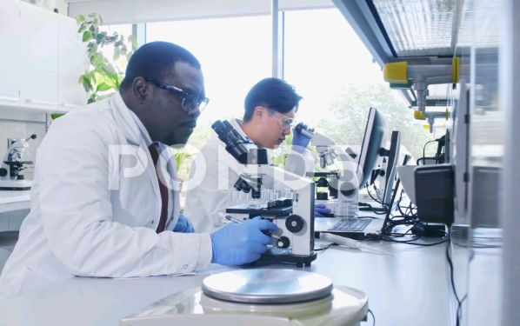 | 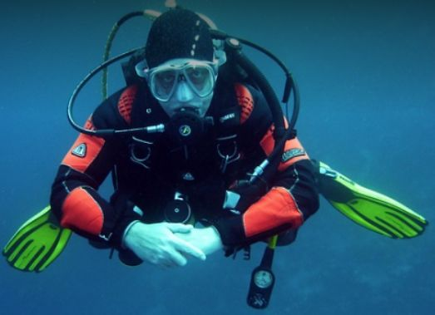
Task;
As chemistry students, make a write up you will undertake in the production process. (15mks)
Item 4
Ethanol is a renewable fuel got from various plant materials collectively known as biomass.
Due to a wide spread of conjuctivities commonly known as “RED EYES” disease in the country today, there is an increased demand for ethanol to make hand sanitizers to reduce on the spread of the disease. The government supply for Ethanol is not enough and has encouraged the local people to manufacture ethanol with minimal environmental impact and sell it to the government.
However; your family members have no idea on how the process of production can be carried out and they would wish to Make some money.
Picture of a woman locally making alcohol
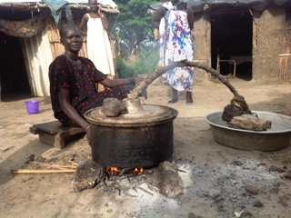

Task;
As a student of chemistry; prepare a write up that you will use to educate your family members during the get together dinner. (15mks)
PART II (Answer one item from this part).
Item 5
Natural resources have been destroyed as a result of increasing human population and human activities. This has attracted the attention of the officials from the National Environmental Management Authority (NEMA). The officials are planning to create awareness to the people of the country through sensitization workshops organized in different district communities.
Picture of deforestation | Picture of charcoal burning
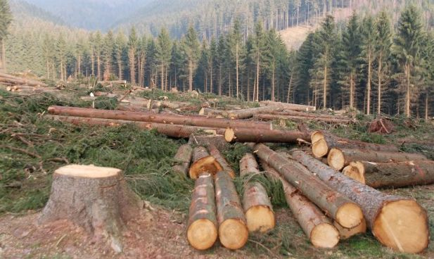 | 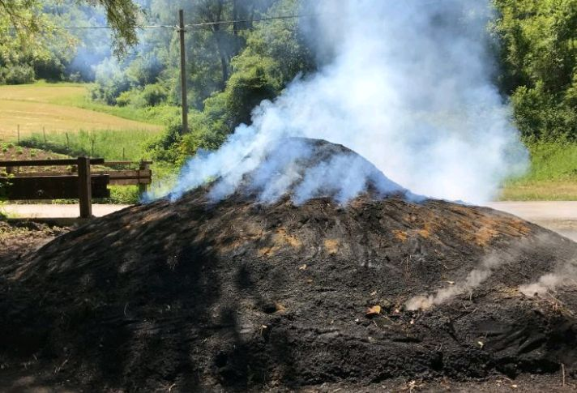
Task;
Prepare a speech you will deliver during the workshop upon the invitation. (15mks)
Item 6
Masese ferry landing site in Jinja is one of the busiest water transport used in the country. For the effectiveness of this heavy-duty ferry, it is built with an Anchor as shown.
This is connected to heavy and strong chains before it is suspended to the river bed to prevent it from drifting due to the wind or current.
During a routine servicing of this water vessel (August 2023), the Anchor was got damaged and coated by brown layers making it weaker and caused imbalance during floating.
Picture of Anchor of ferry in the water | Picture of rusted Anchor
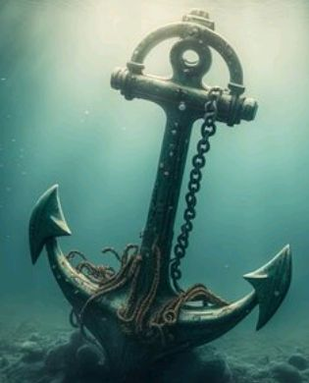 | 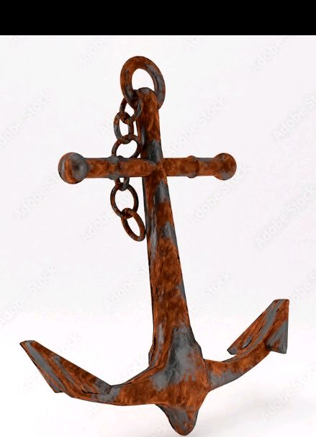
Task;
Explain how this coating and damages on the Anchor occurred and the possible measures to stop its re-occurance. (15mks)

